Safeguarding Statement

At Avonmouth Children’s Centre we work with children, parents and the community to give them the very best possible start in life.

All staff are committed to safeguarding all children, young people and vulnerable adults that we come into contact with.

We focus on building open, trusting, supportive and respectful relationships with the families we support and in environment in which children are safe.

Safeguarding the welfare of children is paramount and it is everyone’s responsibility to take action if they have concerns.

Our full safeguarding policy is available from a member of staff or on our website.

The management and leadership team with specific safeguarding responsibilities are:

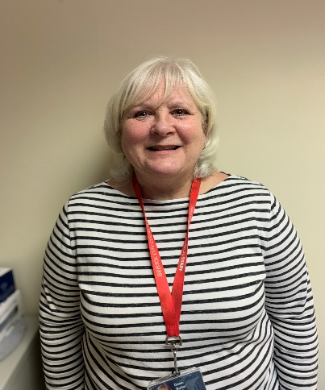
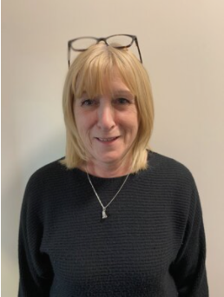

Annette Dickson
Deputy Designated Safeguarding Lead

Kitty Tomlin
Designated Safeguarding Lead

Dawn Butler
Early Years Service Manager

